API Documentation

Name – Shagun Somani, Email [-shagun.somani1@gmail.com](mailto:-shagun.somani1@gmail.com)

# For the first three tasks

Just write the command node TRJ.js in the command prompt where the file is present

Code

**Unique Elements in array**

Two Nested loops are used to find if the element is already present in the output array or not, if not the element is pushed into the output array

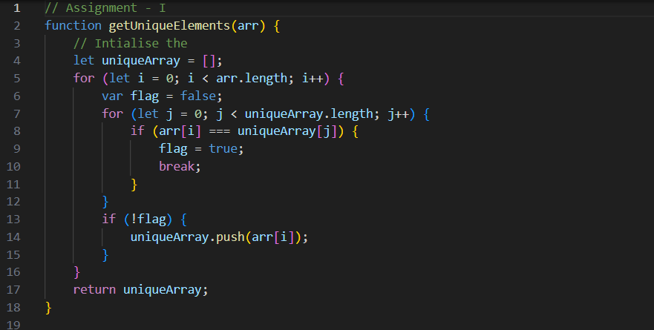

**Merging of two objects**

Merged function is used to merge two objects while maintain the properties of the two objects in the new object

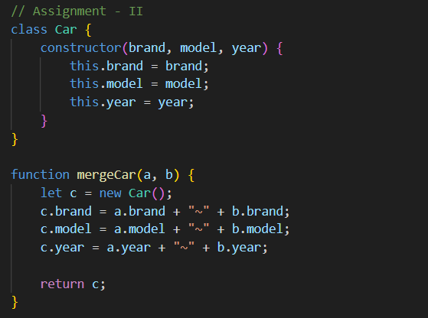

**Merging two arrays and getting unique elements in the output array**

First all the elements of the first array is stored inside in the set and output array and then the array2 is iterated to and if the element in the array2 is not present in the set the element is pushed to the resultant array

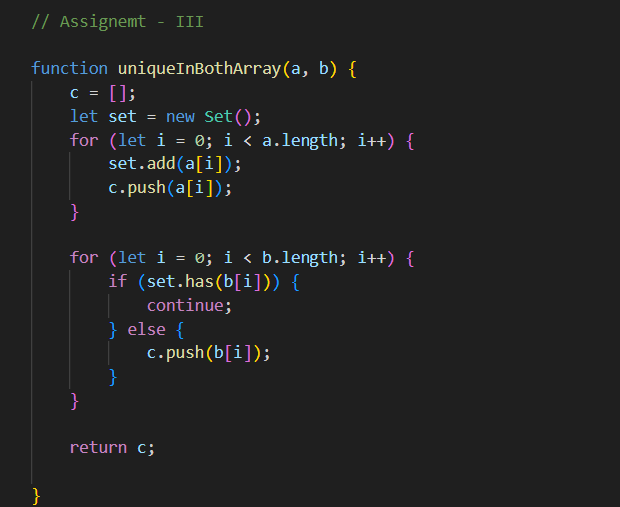

Input

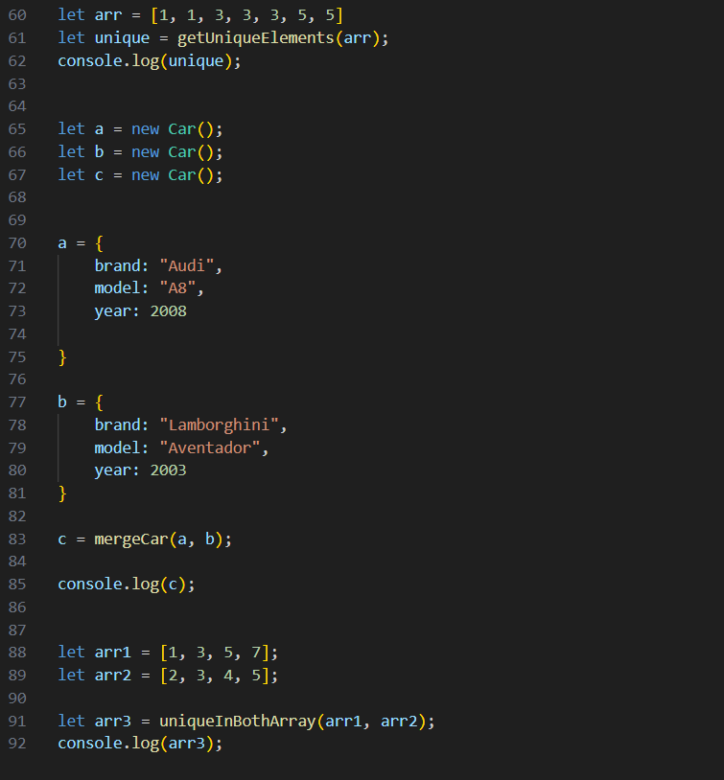

Output

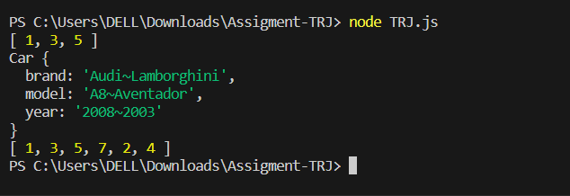

# API Installation

1. Open the folder
2. In the terminal go into the directory of the folder and write command npm init (Given the node is already installed if not please refer this [Link](https://nodejs.org/en/learn/getting-started/how-to-install-nodejs)
3. Install express (npm i -g express)
4. Install body-parser (npm i -g body-parser)
5. Write Command node TRJ-API.js in the prompt inside the folder where file is present, to run the JS file of APIs
6. One can test the APIs by using POSTMAN

Initialisation of array of the books

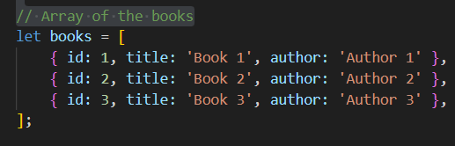

Middleware functions to log the timestamp and type of

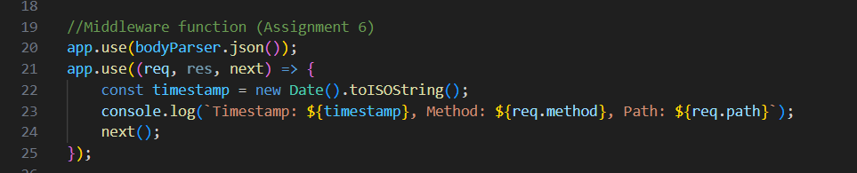

**GET API**

Code

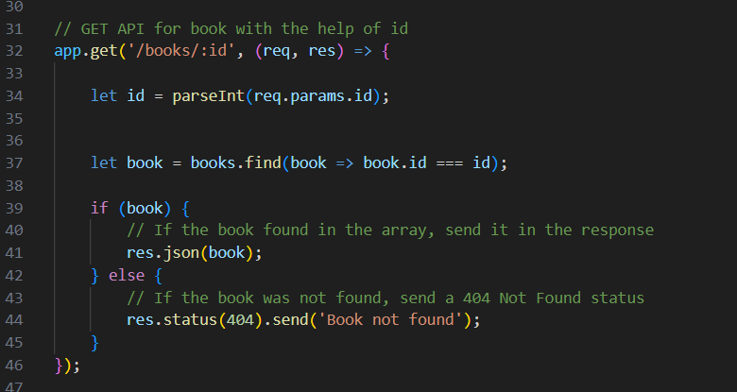

Test through Postman

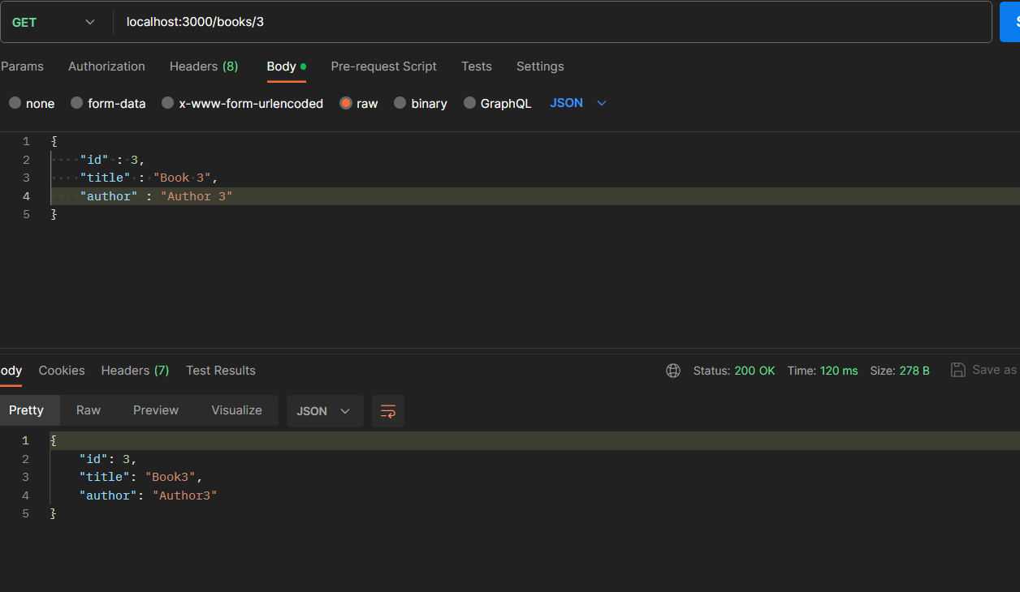

Output on console

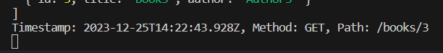

**POST API**

Code

Here the input provided in the form of json would be added to the array of the books

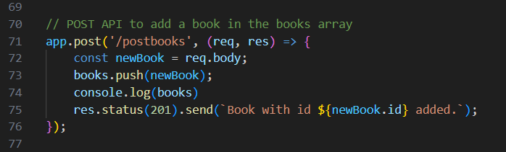

Test Through POSTMAN here we pass the book in json format

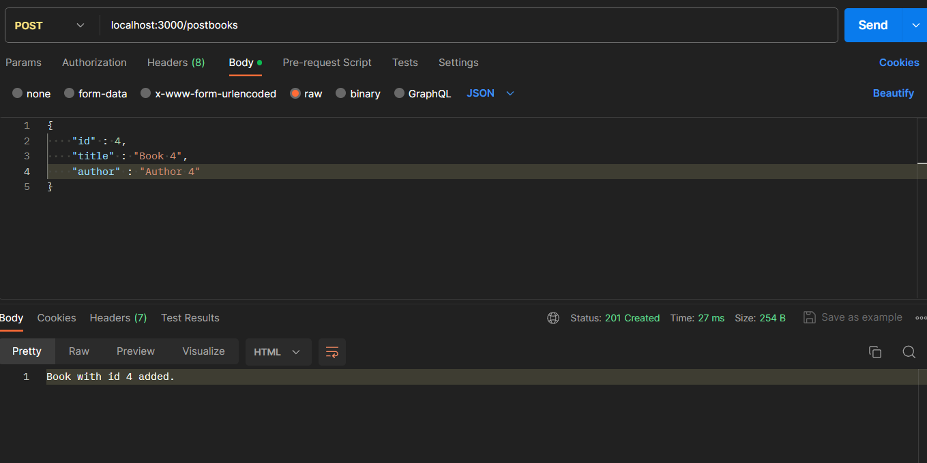

Output

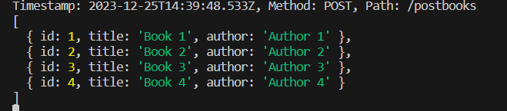

**PUT API**

Code

Here using url parameter we update the book we want to update by finding the id

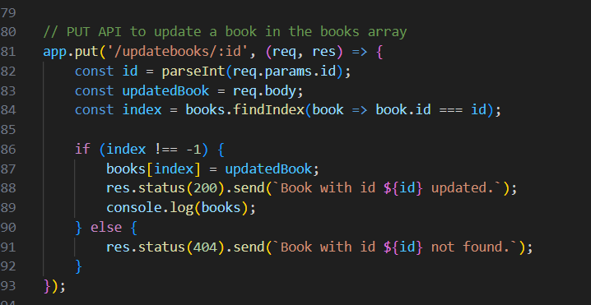

Test Through Postman

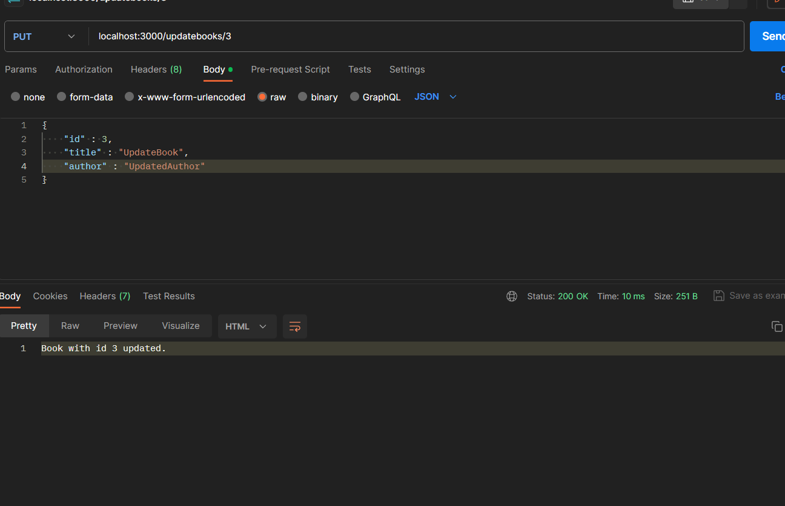

Output

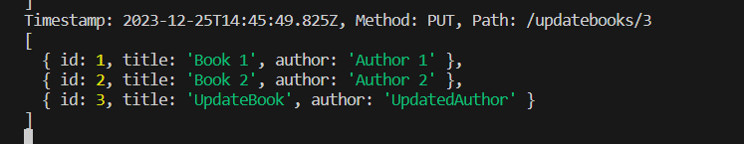

**DELETE API**

Code

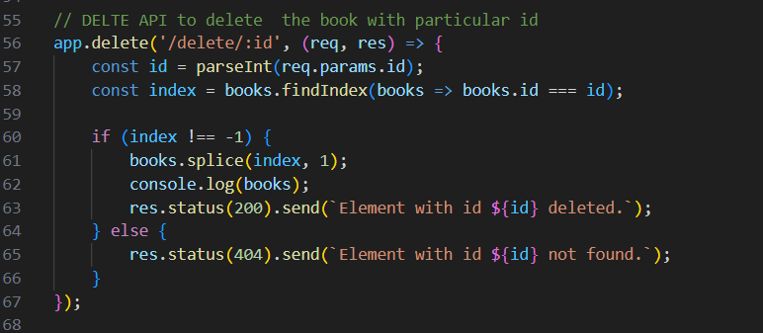

Test Through Postman

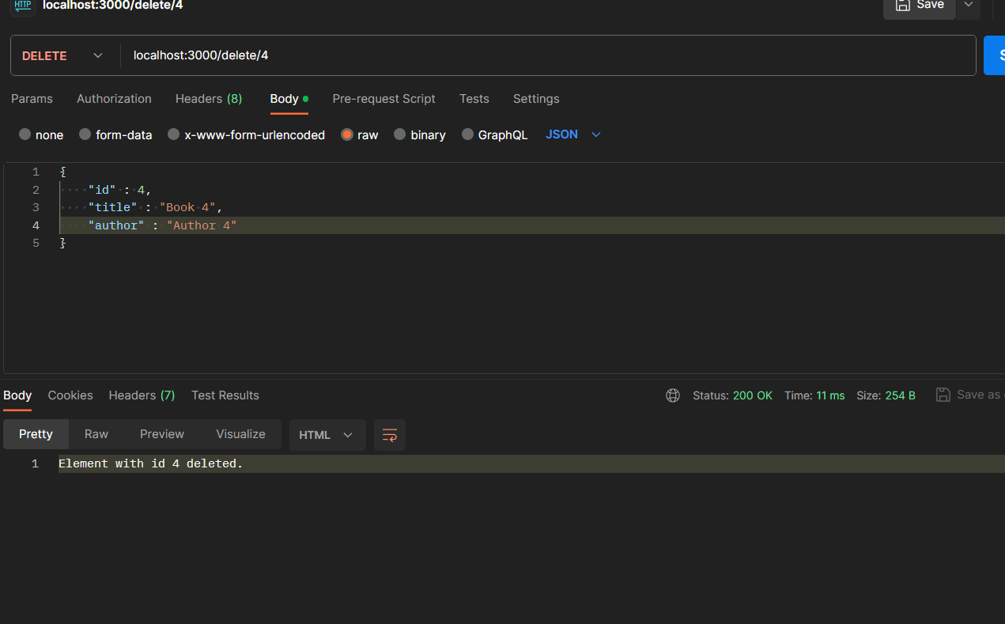

Output

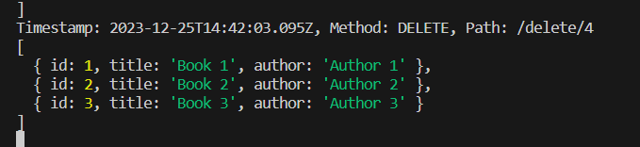

## Unit test of POST and PUT APIs

1. npm install --save-dev jest supertest write this command in the command prompt to install jest and superset in the system
2. Make sure that the TRJ-API.js is running to run the tests
3. In package.json folder add the line in the “scripts” given below



1. Inside the folder where api.test.js is present write command jest.cmd api.test.js to run the test

Output

